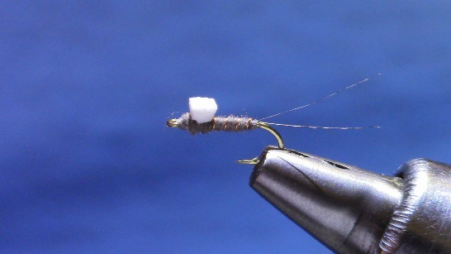
Copper Ribbed RS-2 HOOK: Dai Riki 310 #16 THREAD: 8/0 gray TAIL: Coq de Leon tailing fibers RIB: Ultra wire, copper, small (xsm for smaller sizes than #16) ABDOMEN: Superfine, Adams Gray Wing post/bud: Craft foam, 2mm x 2mm (1.5 x 1.5 for #20 and smaller)

- Attach thread mid-shank. Tie two fibers Coq de Leon (“CDL”), measured at a bit longer than the shank length. Spin thread to round. Wrap tail to hook barb.
- To divide tails, make one turn of thread under the tails, and pull thread forward. Rounded thread will lift and separate tail fibers. Gently make a second HALF wrap, sliding the thread between the tails from underneath, finishing by holding the thread straight up. Gently, continue the rest of the wrap AWAY from you and slightly FORWARD. Control thread tension to set the tails.
- Tie in copper wire, on near side of hook. Leave a slight gap between the tail fibers and the copper wire tie in point.
- Dub tightly and thinly, including a turn or two BEHIND the copper wire. Dub an even, or very slightly tapered, abdomen, ending 1 eye length behind the hook eye.
- Rib forward, 4-5 turns is about right
- Trim the end of a 2mm square foam post at a slight angle. Tie the foam post on the gap you left behind the eye, tying in on the thinner edge you created by trimming the post.
- Dub to finish the body/head, including some wraps in front of and behind post. Trim post to square, or a bit flatter.
- Whip and fish.

